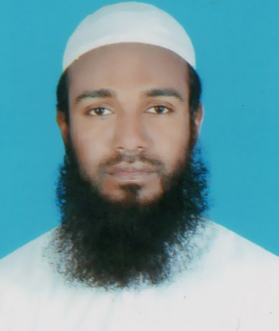 **ALAMGIR HOSSEN**

CHARLXMIKUL, NATORE SADAR, NATORE

Cell No: +8801736-843080

Email: s.m.alamgirhossen1990@gmail.com

**CAREEN OBJECTIVES**

To find a suitable position in a reputed electronics company and render my service with devotion , honesty and sincerity for the development of my country as well as my company and be succeed in my future.

**EDUCATIONAL ATEAINMENT**

**DEGREE : SECONDARY SCHOOL CERTIFICATE**

Year of passing : 2006

Group : Humanities

GPA : 3.69/5 Scale

**DEGREE : HIGHER SECONDARY CERTIFICATE**

Year of passing : 2008

Group : Business Studies

GPA : 4.20/5 Scale

**DEGREE : BACHELOR OF ARTS**

Year of passing : 2013

Subject : English

Division : 3rd Class

Board : National University.

**DEGREE : MASTERS OF ARTS**

Year of passing : 2014

Subject : English

GPA : 2.61/4 Scale

Board : National University.

**EXPEIENCE SKILLS**

**Job experience:** Myone Electronics Ind. Ltd. & Minister Hi-Tec Park Ltd.

Designation: Marketing Officer. (Showroom)

Duration: 17 Sep. 2016 to Continue.

**COMPUTER SKILLS**

**Application Software :** MS word, MS excel, MS power point, MS Access, Internet etc.

**LINGUISTIC PROFICIENCY**

**Good command in English, Bangla and Arabic.**

**COMPUTER SKILLS**

To manage people

**SPECIAL ABILITY**

Determinant and sincere to work.

To take challenge and responsibility.

Self-motivated and self-confident.

**INTERESTS**

Traveling, Reading books and Writing

**PERSONAL PROFILE**

Father's Name : Md. Sabder Hossen

Mother's Name : Shirina Begum

Permanent address : Vill: Charloxmikul, P.O: Baddobelghoria,

P.S: Natore Sadar, Dist: Natore.

Birth Date : 15th December 1990

***REFERENCE*:**

|  |  |
| --- | --- |
| Md. Tipu Sultan  Assistant Professor  Azizul Haque Govt. College,  Bogra.  Mob: 01712-263792 | Mohammad Kamal Hossain  Assistant Divisional Manager  Showroom Division  Myone Energy Ltd.  Mob: 01990-403005 |

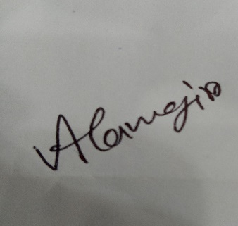

**Signature**

**Alamgir Hossen**

Date: 07/08/2017